Учреждение образования

«Белорусский государственный технологический университет»

**Лабораторная работа №5**

Алгоритмы на графах

(Алгоритмы поиска в ширину и глубину, топологическая сортировка)

Выполнил:

Студент 2 курса 1 группы ФИТ

Шумова Елизавета Игоревна

**2022 г.**

**Цель:** освоить сущность и программную реализацию: а) способов представления графов; б) алгоритмов поиска в ширину и глубину; в) алгоритма топологической сортировки графов.

**Вариант 13**

**Задание №1. Алгоритм поиска в ширину (BFS)**

Исходный граф:

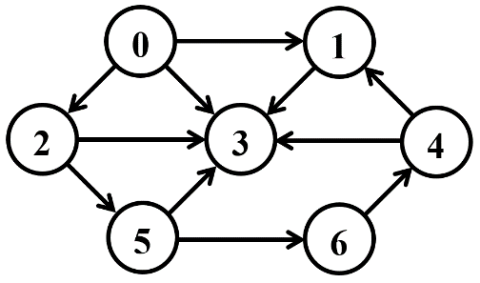

Текущее состояние алгоритма хранится в следующих структурах памяти:

Q – очередь вершин,

C – массив окраски вершин,

D – массив расстояний,

P – массив предшествующих вершин.

Шаг 0.

|  |  |  |  |  |  |  |  |
| --- | --- | --- | --- | --- | --- | --- | --- |
| Q | 0 |  |  |  |  |  |  |
| C | G | W | W | W | W | W | W |
| D | 0 | I | I | I | I | I | I |
| P | N | N | N | N | N | N | N |

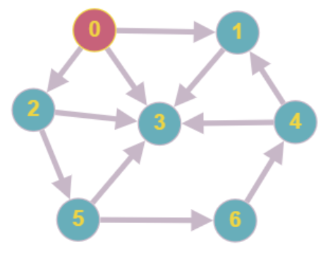

Шаг 1.

|  |  |  |  |  |  |  |  |
| --- | --- | --- | --- | --- | --- | --- | --- |
| Q | 1 |  |  |  |  |  |  |
| C | B | G | W | W | W | W | W |
| D | 0 | 1 | I | I | I | I | I |
| P | N | 0 | N | N | N | N | N |

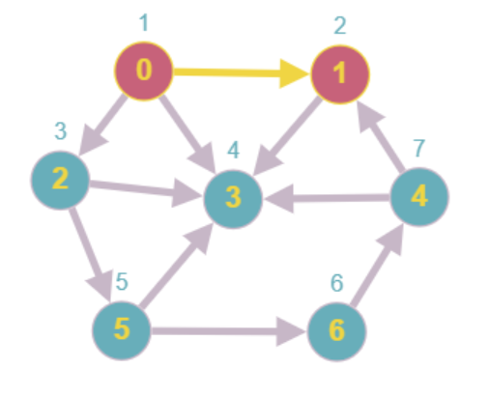

Шаг 2.

|  |  |  |  |  |  |  |  |
| --- | --- | --- | --- | --- | --- | --- | --- |
| Q | 2 |  |  |  |  |  |  |
| C | B | B | G | W | W | W | W |
| D | 0 | 1 | 2 | I | I | I | I |
| P | N | 0 | 1 | N | N | N | N |

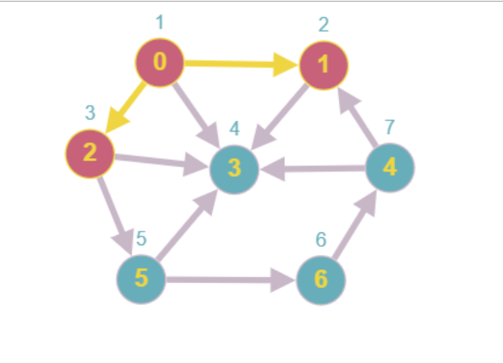

Шаг 3.

|  |  |  |  |  |  |  |  |
| --- | --- | --- | --- | --- | --- | --- | --- |
| Q | 3 |  |  |  |  |  |  |
| C | B | B | B | G | W | W | W |
| D | 0 | 1 | 2 | 3 | I | I | I |
| P | N | 0 | 1 | 2 | N | N | N |

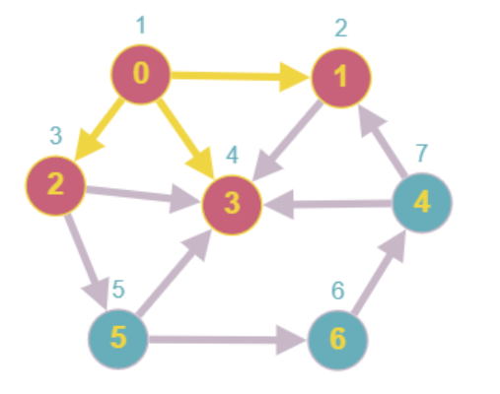

Шаг 4.

|  |  |  |  |  |  |  |  |
| --- | --- | --- | --- | --- | --- | --- | --- |
| Q | 5 |  |  |  |  |  |  |
| C | B | B | B | B | G | W | W |
| D | 0 | 1 | 2 | 3 | 5 | I | I |
| P | N | 0 | 1 | 2 | 3 | N | N |

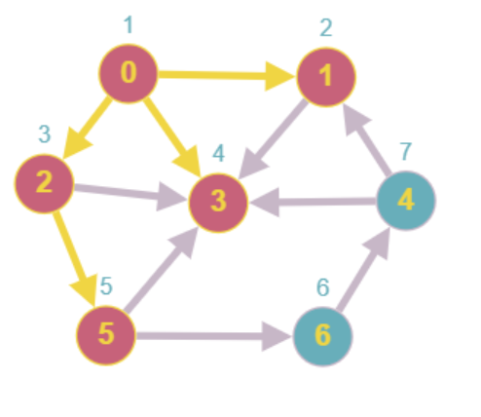

Шаг 5.

|  |  |  |  |  |  |  |  |
| --- | --- | --- | --- | --- | --- | --- | --- |
| Q | 6 |  |  |  |  |  |  |
| C | B | B | B | B | B | G | W |
| D | 0 | 1 | 2 | 3 | 5 | 6 | I |
| P | N | 0 | 1 | 2 | 3 | 5 | N |

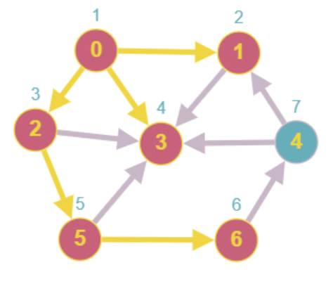

Шаг 6.

|  |  |  |  |  |  |  |  |
| --- | --- | --- | --- | --- | --- | --- | --- |
| Q | 4 |  |  |  |  |  |  |
| C | B | B | B | B | B | B | G |
| D | 0 | 1 | 2 | 3 | 5 | 6 | 4 |
| P | N | 0 | 0 | 0 | 2 | 5 | 6 |

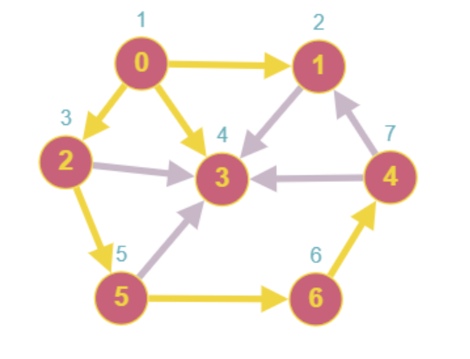

Шаг 8.

|  |  |  |  |  |  |  |
| --- | --- | --- | --- | --- | --- | --- |
| Q |  |  |  |  |  |  |
| C | B | B | B | B | B | B | B |
| D | 0 | 1 | 2 | 3 | 5 | 6 | 4 |
| P | N | 0 | 0 | 0 | 2 | 5 | 6 |

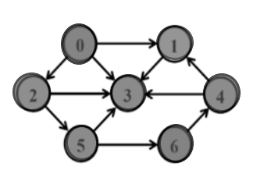

Все вершины черного цвета, алгоритм завершил свою работу.

В результате получили BFS-дерево:

|  |  |  |  |  |  |  |  |
| --- | --- | --- | --- | --- | --- | --- | --- |
| D | 0 | 1 | 2 | 3 | 5 | 6 | 4 |

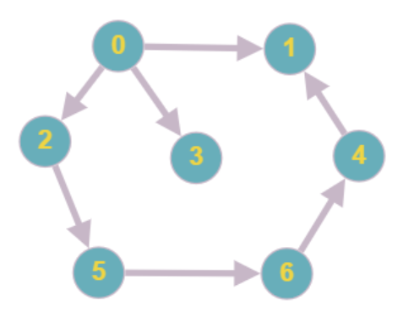

**Алгоритм поиска в глубину (DFS)**

Исходный граф:



Текущее состояние алгоритма хранится в следующих структурах памяти:

C – массив окраски вершин,

D – время окраски вершин в серый цвет,

P – массив предшествующих вершин,

F – время окраски в чёрный цвет,

t – номер шага алгоритма.

Шаг 1

|  |  |  |  |  |  |  |  |
| --- | --- | --- | --- | --- | --- | --- | --- |
| C | B | G | W | W | W | W | W |
| D | 0 | 1 | I | I | I | I | I |
| P | N | 0 | N | N | N | N | N |
| F | 0 | 0 | 0 | 0 | 0 | 0 | 0 |

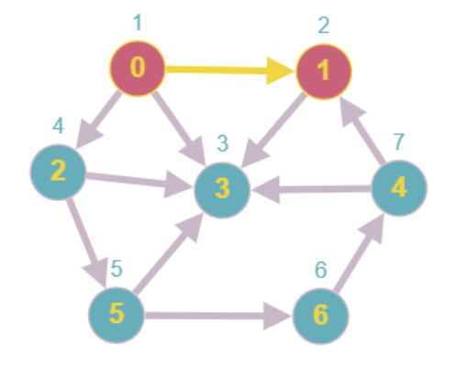

Шаг 2

|  |  |  |  |  |  |  |  |
| --- | --- | --- | --- | --- | --- | --- | --- |
| C | B | B | G | W | W | W | W |
| D | 0 | 1 | 3 | I | I | I | I |
| P | N | 0 | 1 | N | N | N | N |
| F | 0 | 0 | 2 | 0 | 0 | 0 | 0 |

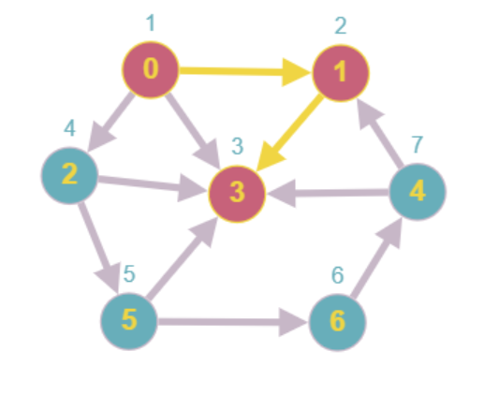

Шаг 3

|  |  |  |  |  |  |  |  |
| --- | --- | --- | --- | --- | --- | --- | --- |
| C | B | B | B | G | W | W | W |
| D | 0 | 1 | 3 | 2 | I | I | I |
| P | N | 0 | 1 | 3 | N | N | N |
| F | 0 | 0 | 2 | 0 | 0 | 0 | 0 |

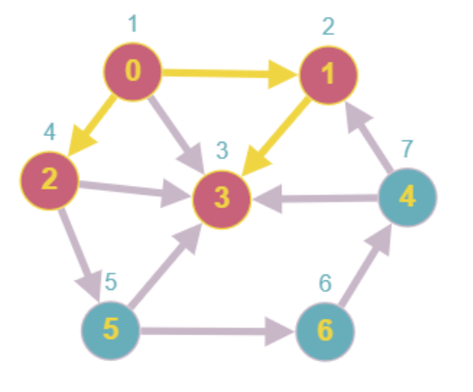

Шаг 4

|  |  |  |  |  |  |  |  |
| --- | --- | --- | --- | --- | --- | --- | --- |
| C | B | B | B | B | G | W | W |
| D | 0 | 1 | 3 | 2 | 5 | I | I |
| P | N | 0 | 1 | 3 | 2 | N | N |
| F | 0 | 0 | 2 | 0 | 0 | 0 | 0 |

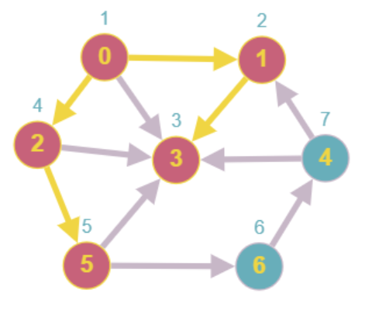

Шаг 5

|  |  |  |  |  |  |  |  |
| --- | --- | --- | --- | --- | --- | --- | --- |
| C | B | B | B | B | B | G | W |
| D | 0 | 1 | 3 | 2 | 5 | 6 | I |
| P | N | 0 | 1 | 3 | 2 | 5 | N |
| F | 0 | 0 | 2 | 0 | 0 | 0 | 0 |

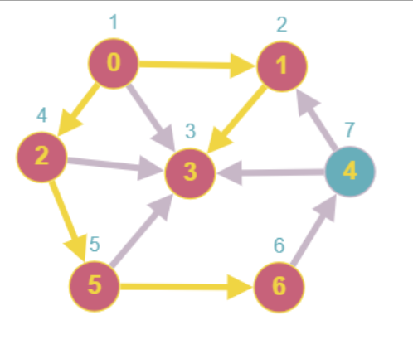

Шаг 6

|  |  |  |  |  |  |  |  |
| --- | --- | --- | --- | --- | --- | --- | --- |
| C | B | B | B | B | B | B | B |
| D | 0 | 1 | 3 | 2 | 5 | 6 | 4 |
| P | N | 0 | 1 | 3 | 2 | 5 | 6 |
| F | 0 | 0 | 2 | 0 | 0 | 0 | 0 |

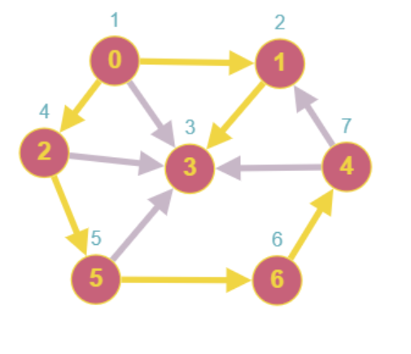

В результате получили DFS-дерево:

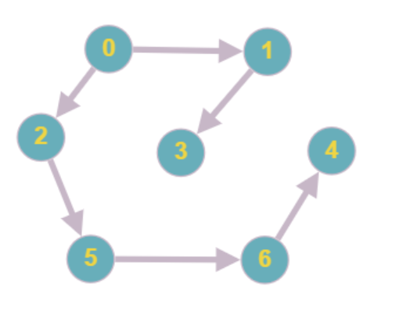

**Топологическая сортировка.**



Матрица смежности:

|  |  |  |  |  |  |  |  |
| --- | --- | --- | --- | --- | --- | --- | --- |
|  | 0 | 1 | 2 | 3 | 4 | 5 | 6 |
| 0 | 0 | 0 | 0 | 0 | 0 | 0 | 0 |
| 1 | 0 | 0 | 0 | 0 | 0 | 0 | 0 |
| 2 | 0 | 0 | 0 | 0 | 0 | 0 | 0 |
| 3 | 0 | 0 | 0 | 0 | 0 | 0 | 0 |
| 4 | 0 | 0 | 0 | 0 | 0 | 0 | 0 |
| 5 | 0 | 0 | 0 | 0 | 0 | 0 | 0 |
| 6 | 0 | 0 | 0 | 0 | 0 | 0 | 0 |

0-2-5-6-4-1-3

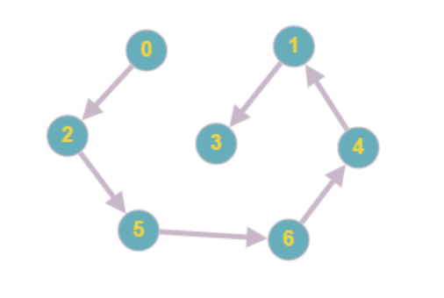

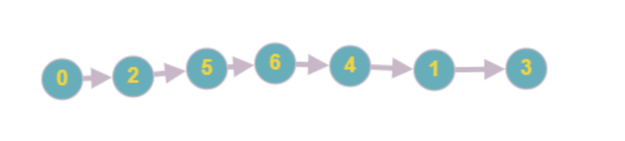

Результат выполнения программы:

